**Forest Fire Warning and Mitigation System**



**ABSTRACT:**

This project focuses on developing an automated fire detection and suppression system using a flame sensor and Raspberry Pi. The system detects flames in its vicinity and, upon detection, activates a water pump to extinguish the fire, making it a practical solution for fire prevention and mitigation in various settings, such as homes, offices, and industrial areas. The Raspberry Pi acts as the control unit, processing data from the flame sensor and triggering the water pump when necessary.



**INDEX**

1. Introduction
2. Background
3. Problem Definition
4. Proposed System Block Diagram
5. Objectives
6. Methodology 6.1.Hardware components
   1. Software components
   2. Raspberry PI 4B
   3. 5-Channel Flame Sensor
   4. Relay Module
   5. Water Pump
7. Results
8. Conclusion
9. Future scope
10. Reference
11. Appendix



# Introduction

The **Forest Fire Warning and Mitigation System** is designed to monitor and respond to forest fires in real-time, providing early detection and triggering immediate actions to mitigate the damage caused by wildfires. The system uses a combination of environmental sensors and automated control mechanisms to detect signs of fire and take preventive actions, such as activating water sprinklers or sending alerts to relevant authorities.

The project aims to integrate flame sensors, smoke detectors, and environmental data to identify the presence of fire in forested areas. Upon detecting abnormal conditions, the system triggers a series of events, such as activating fire suppression mechanisms like water pumps or releasing fire retardants, depending on the severity of the fire. Furthermore, a communication system sends alerts to local emergency responders, enabling swift action to prevent the fire from spreading.

Key features of the system include:

* + **Real-Time Monitoring**: Continuously tracks temperature, humidity, and flame detection.
  + **Automated Response**: Activates firefighting systems like water motors based on sensor input.
  + **Remote Alerts**: Sends notifications to emergency services for quick intervention.
  + **Scalability**: Adaptable to different forest areas and environmental conditions.

This project not only focuses on the technical implementation of a forest fire warning system but also aims to contribute to the larger goal of reducing the devastating impact of forest fires on ecosystems, wildlife, and human settlements.



# Background

Forest fires pose a significant threat to ecosystems, property, and human life. Rapid detection and response are crucial in minimizing damage and protecting lives. Traditional fire-detection methods often rely on human surveillance or satellite imaging, which can be delayed and costly. The need for efficient, automated systems has driven technological innovations aimed at early detection and immediate action. A forest fire warning and mitigation system is designed to address this need by leveraging sensors and automation to identify and respond to fires before they spread uncontrollably.

This system uses a Raspberry Pi, a relay module, a 5-channel flame sensor, and a water motor to continuously monitor for signs of fire. Once detected, it activates water pumps to douse the flames, aiming to contain the fire at its early stage. By automating the detection and response process, this solution can potentially save valuable time and resources, contributing to more effective forest fire management.

# Problem Definition

The **problem definition** for the Forest Fire Warning and Mitigation System revolves around the growing threat of wildfires in forested areas, which can cause significant environmental damage, loss of wildlife, and threaten nearby human settlements. Traditional methods of detecting and managing forest fires are often slow and reactive, leading to delayed responses and increased damage.

This project aims to address these challenges by creating an integrated, sensor-based system for early fire detection, automated firefighting response, and real-time alerting, ultimately improving forest fire management and reducing the risk to ecosystems and human life.



1. **Proposed system Diagram:**

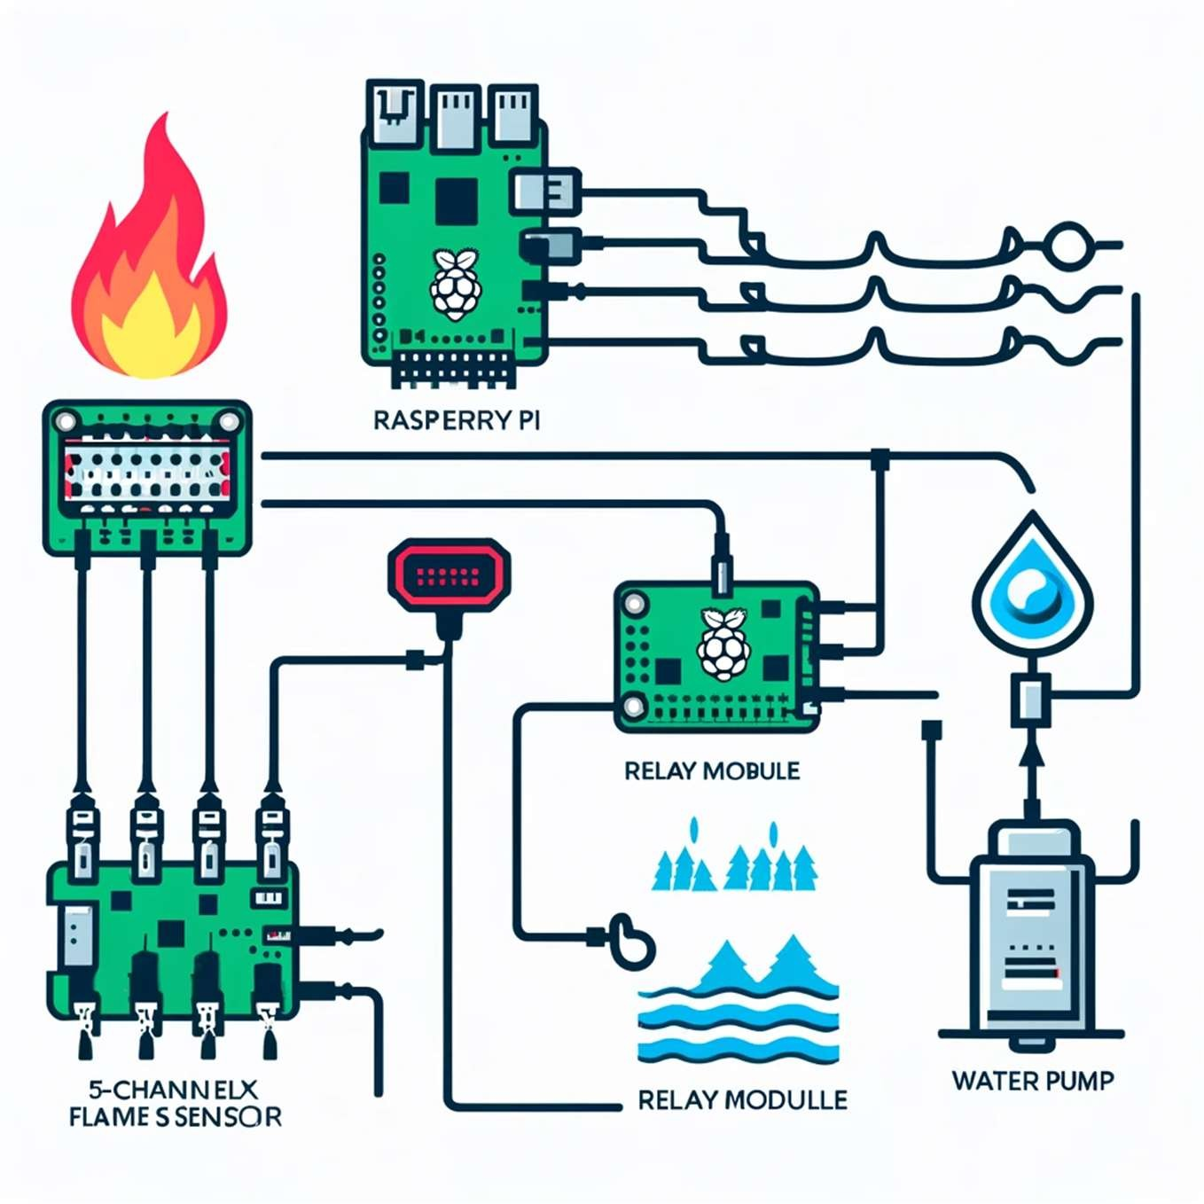

1. **Objective:**

Objective of the Forest Fire Warning and Mitigation System:

The primary objective of this system is to detect forest fires early and automatically respond to them to minimize damage. The system uses a combination of Raspberry Pi, a 5-channel flame sensor, a relay module, and a water pump to achieve this goal. The key objectives are:

1. Early Detection of Fire:
   * Utilize the 5-channel flame sensor to detect the presence of fire or flames in the forest area in real-time.
   * Ensure quick and accurate detection to trigger prompt action, thereby reducing response time.



1. Automated Fire Suppression:
   * Once a fire is detected, the Raspberry Pi processes the signal from the flame sensor.
   * The Raspberry Pi then triggers the relay module to activate the water pump automatically.
   * The water pump sprays water to suppress or extinguish the fire, helping prevent the fire from spreading.
2. Minimizing Human Intervention:
   * Automate the fire detection and suppression process to reduce the need for manual monitoring.
   * This ensures safety for forest personnel by reducing the risk of exposure to potentially hazardous fire zones.
3. Efficient Resource Management:
   * Optimize the use of water and energy by activating the pump only when a fire is detected, thus conserving resources.
4. Scalability and Reliability:
   * The system is designed to be scalable, allowing for the addition of more sensors or pumps as needed for larger forest areas.
   * Aim to build a reliable system that can function effectively in harsh environmental conditions.

By achieving these objectives, the system aims to mitigate the impact of forest fires, protect wildlife, and reduce the destruction of natural resources.



# Methodology

The methodology for the forest fire warning and mitigation system includes the detailed process of setting up the system and its components, as well as the sequence of operations performed to detect and respond to fire.

## System Initialization:

The system begins with initializing the Raspberry Pi’s GPIO pins to interact with various components, including flame sensors and a relay module connected to a water pump.

## Flame Detection:

The Raspberry Pi monitors the flame sensors continuously. Each sensor gives a binary output (HIGH for flame detected, LOW for no flame). If a flame is detected by any sensor, it triggers an event in the system to initiate mitigation.

## Relay Activation and Water Pump Operation:

Upon flame detection, the Raspberry Pi sends a signal to activate the relay module. The relay then powers the water pump to release water, aiming to extinguish the detected fire.

## Real-Time System Feedback:

The system provides real-time console output to indicate sensor status (flame detected or not) and relay activation (pumping water or not). This feedback ensures continuous monitoring and allows for system adjustments as needed.

## System Shutdown and GPIO Cleanup:

When manually shut down, the Raspberry Pi executes a GPIO cleanup function to safely reset pins and ensure all components are safely powered down.

## Components:

* 1. Hardware Components

 Raspberry Pi Model 4  Flame Sensor

 Relay Module



 HW Battery  Jumper Wires

* 1. Software Components
     + Python Programming Language
     + RPi.GPIO Library for GPIO control
  2. Raspberry Pi Model 4
     + Function: The Raspberry Pi Model 4 serves as the main control unit of the system. It processes inputs from flame sensors and controls the relay module to operate the water pump.
     + Setup: The Raspberry Pi is configured with the RPi.GPIO library to interact with the connected hardware components. Its GPIO pins are used to receive signals from flame sensors and to control the relay.
     + Programming: Python code is run on the Raspberry Pi, continuously monitoring the sensors and responding to any detected flames by triggering the mitigation mechanism.
  3. Flame Sensor
     + Purpose: Flame sensors detect the presence of fire by sensing infrared radiation emitted by flames.
     + Operation: Each flame sensor outputs a binary signal (HIGH when a flame is detected, LOW when no flame is present) that the Raspberry Pi reads. Multiple sensors are used to cover a wider area and improve detection reliability.
     + Connection: The sensors are connected to specific GPIO pins on the Raspberry Pi, allowing the control unit to monitor each sensor’s state individually.
  4. Relay Module
     + Function: The relay module acts as a switch that controls the water pump based on signals from the Raspberry Pi.
     + Operation: When the Raspberry Pi detects a flame, it sends a HIGH signal to the relay, which closes the circuit and powers the



water pump. When no flame is detected, the relay circuit remains open, and the pump is off.

* + - Setup: The relay module is connected to both the Raspberry Pi and the water pump, enabling the Raspberry Pi to switch the pump on and off as needed.
  1. HW Battery
     + Purpose: The HW battery provides power to the system, ensuring that the Raspberry Pi, sensors, and relay module remain operational in remote areas without access to electricity.
     + Specification: The battery’s capacity is chosen to ensure continuous power for the Raspberry Pi and other components, supporting reliable operation over extended periods.
     + Connection: The battery is connected to the power input of the Raspberry Pi and other components as needed.
  2. Jumper Wires
     + Use: Jumper wires connect all components in the system, allowing for efficient data transfer and power distribution.
     + Types and Arrangement: Various jumper wires (male-to-male, female-to-male) are used depending on the connection points on the Raspberry Pi, sensors, relay, and battery.
     + Importance: Proper wiring ensures stable connections and reduces signal interference, which is critical for the real-time performance of the fire detection.



# Result

The **Forest Fire Warning and Mitigation System** successfully addresses key challenges by providing quick fire detection, enabling early intervention to prevent the spread of fire. It automatically activates firefighting systems, minimizing reliance on human action and reducing errors. The system ensures continuous monitoring of remote forest areas without the need for human presence, using sensors to gather real-time data. Additionally, the system is scalable, adapting to different terrains and expanding to cover larger areas, improving overall fire management and reducing damage from forest fires.

Images of the prototype:

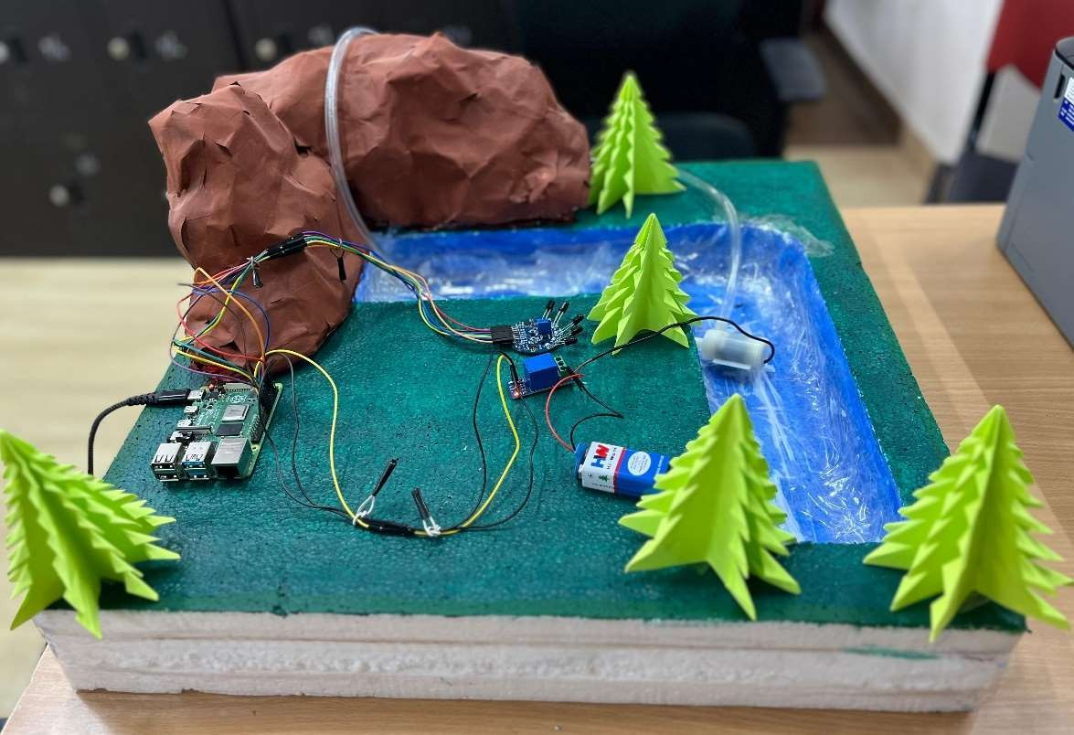



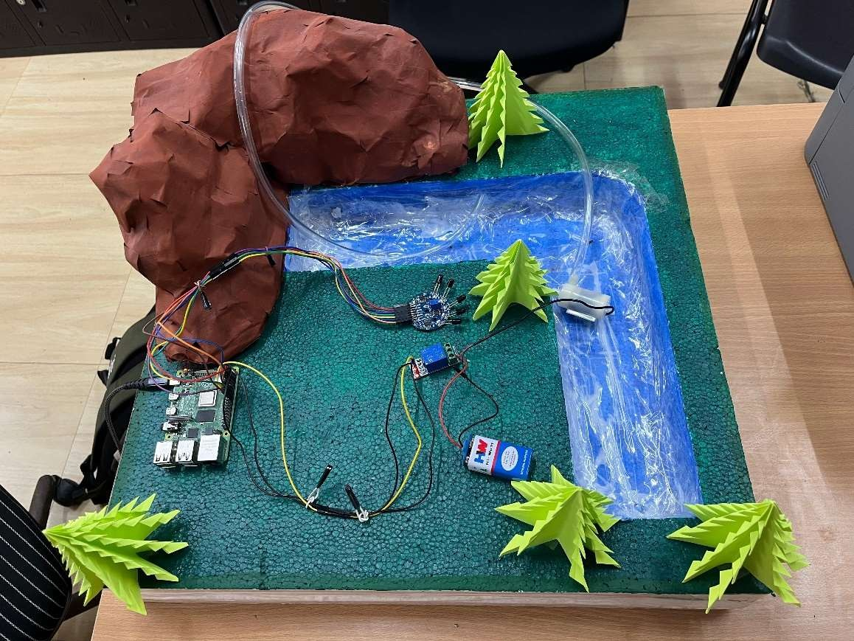

# Conclusion

In conclusion, the **Forest Fire Warning and Mitigation System** presents a reliable and effective solution for early detection, automated response, and real-time monitoring of forest fires. By addressing key challenges such as fire detection, remote monitoring, and scalability, the system significantly reduces the risks associated with forest fires. Its ability to trigger automated firefighting mechanisms and send real- time alerts ensures rapid intervention, potentially saving ecosystems, wildlife, and human lives. This project demonstrates the potential of integrating technology with environmental protection, contributing to a more efficient and responsive fire management system.



# Future Scope

The future scope of a flame sensor-based system using Raspberry Pi includes several key advancements:

1. **Enhanced Accuracy**: Using multiple or advanced sensors like infrared or thermal cameras to improve detection and minimize false alarms.
2. **IOT Integration:** Enabling remote monitoring and control via IoT, allowing real-time alerts and remote operation.
3. **Machine Learning**: Implementing predictive analysis based on environmental conditions to anticipate fire risks and trigger preventive actions.
4. **Environment-Based Adaptation**: Adjusting sensitivity for different environmental conditions to reduce false alarms in certain areas.
5. **Self-Sustaining Systems:** Incorporating renewable energy sources like solar panels for off-grid functionality.
6. **Multi-Purpose Fire Mitigation:** Expanding the system to use various fire-suppressing agents, such as foam or gas, based on the fire type.
7. **Drone Integration:** Using drones for large-scale fire detection and suppression, especially in hard-to-reach areas.

These advancements can make the system more effective, adaptable, and practical for diverse applications, from forests to industrial settings.



# References

 Google - https://[www.ndtv.com/world-news/canada-forest](http://www.ndtv.com/world-news/canada-forest) fire- over-1-000-people-evacuated-a-canadian-fires-engulf town- 2477374

 Raspberry Pi - https://[www.raspberrypi.com](http://www.raspberrypi.com/)  Robocraze

https://robocraze.comcampaignid=17968927099&adgroupid=& keyword=&device=c&gad_source=1&gclid=CjwKCAjwooq3B hB3 EiwAYqYoEkDgcb-7_dXvNrX9AYO77wG5JFrB Zp3BhgjgZYmtWEZiSjMB_kdoRoCiUUQAvD_BwE

 Amazon - https://[www.amazon.in/](http://www.amazon.in/)



1. **Appendix** import RPi.GPIO asGPIO import time

# Define the flame sensor pins flame_sensor_pins=[17, 27, 22, 23, 24] # Define the relay control pin relay_pin =12

# SetupGPIOmodeandwarnings GPIO.setmode(GPIO.BCM) GPIO.setwarnings(False)

# Setup flame sensor pinsasinput for pin in flame_sensor_pins: GPIO.setup(pin, GPIO.IN)

# Setup the relay pin asoutput GPIO.setup(relay_pin, GPIO.OUT) # Initialize relay to OFF state GPIO.output(relay_pin, GPIO.LOW) try:

whileTrue:

flame_detected =False # Flagto checkif flame is detected

for i, pin in enumerate(flame_sensor_pins): if GPIO.input(pin) == GPIO.HIGH: # Flame detected (assuming active-high sensors) print(f"Flame detected on sensor {i+1}")



flame_detected =True # Set flagif any sensor detects flame

else: # Noflame detected

print(f"No Flame detected onsensor {i+1}")

# If flame is detected, activate the relay to pump water

if flame_detected:

GPIO.output(relay_pin, GPIO.HIGH) # Activate the relay (turn it ON)

print("Relay activated: Pumping water!") else:

GPIO.output(relay_pin, GPIO.LOW) # Deactivate the relay (turn it OFF) print("Relay deactivated") time.sleep(1)

except KeyboardInterrupt: print("Program terminated") finally:

GPIO.cleanup()